AUTOWEAVE ENTERPRISE RESOURCE MANAGEMENT SYSTEM
A PROJECT REPORT
Submitted by
ENIGA P
(REG. NO:23BCR015)
GOPIKA S
(REG. NO:23BCR017)

SAMEEKA N
(REG. NO:23BCR046)
in partial fulfilment of the requirements for the award of the degree of
BACHELOR OF SCIENCE
IN

COMPUTER SYSTEMS AND DESIGN
DEPARTMENT OF COMPUTER TECHNOLOGY-UG
KONGU ENGINEERING COLLEGE
(Autonomous)

PERUNDURAI ERODE - 638 060

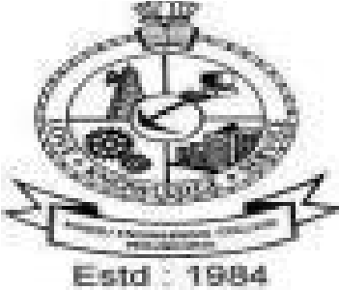

March-2026

